**Ideation Phase**

**Define the Problem Statements**

|  |  |
| --- | --- |
| Date | 25 June 2025 |
| Team ID | LTVIP2025TMID30212 |
| Project Name | SmartSDLC –AI-enhanced software development lifecycle |
| Maximum Marks | 2 Marks |

**Articulating Customer-Centric Problem Statements:**

Understanding user needs is foundational to building impactful software solutions. This section applies the *Customer Problem Statement* framework to empathize with the end users of AI-enhanced software development tools. By stepping into the shoes of students, developers, and software professionals, we define problem statements that reflect their real-world challenges. These statements follow a structured template — identifying the user, their goal, the barriers they face, the reasons behind those barriers, and the emotional impact. This human-centered approach enables the team to craft meaningful, relevant AI solutions that address genuine pain points within the software development lifecycle.

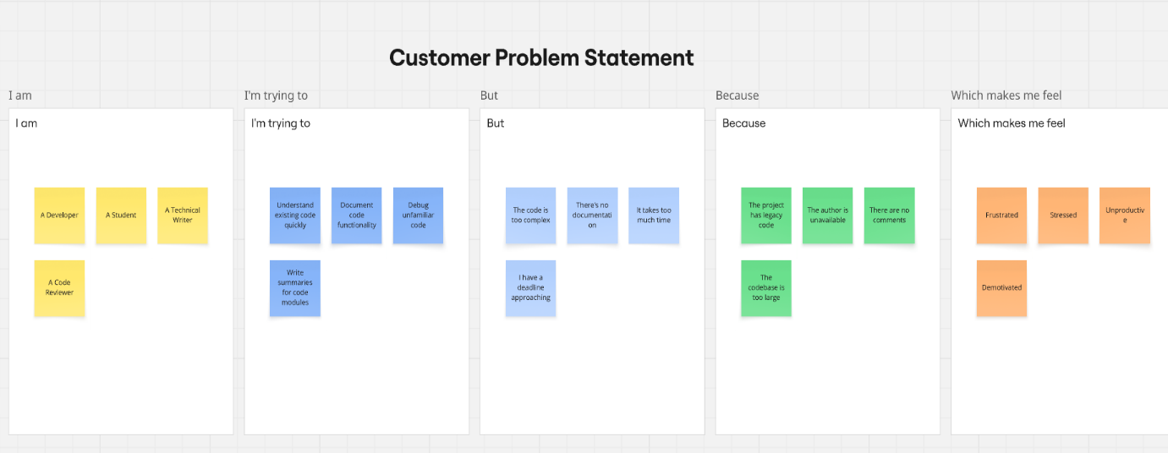

|  |  |  |  |  |  |
| --- | --- | --- | --- | --- | --- |
| **Problem Statement (PS)** | **I am (Customer)** | **I’m trying to** | **But** | **Because** | **Which makes me feel** |
| PS-1 | A developer | Understand large codebases | poorly structured | Manual understanding takes time | frustrated |
| PS-2 | A junior software engineer | Onboard quickly to contribute to the codebase | The code lacks summaries | I need constant help from teammates | anxious |
| PS-3 | A Code Reviewer | Write Summaries | I have a deadline approaching | The codebase is too large | Demotivated |